**Experiment**

**Aim:** Design a smart phone controlled light system.

**Circuit diagram:**

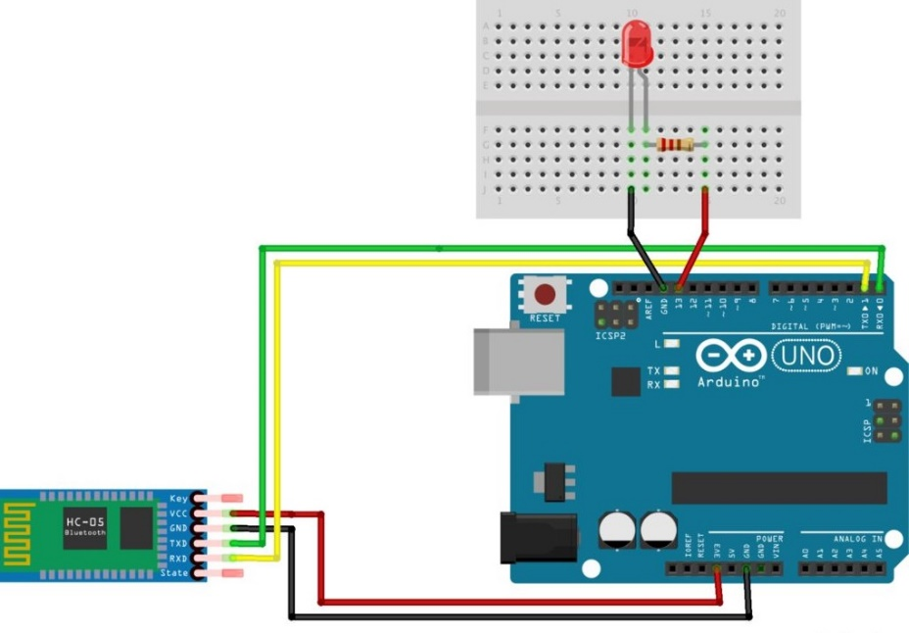

**Theory:**

**CONCEPT USED:**

The android app is designed sending serial data to the Bluetooth module when certain button is pressed. The Bluetooth module at other end receives the data and send to Arduino through the TX pin of Bluetooth module (RX pin of Arduino). The Code fed to Arduino checks the received data and compares. If received data is 1 the LED turns on turns OFF when received data is 0.

**LEARNING AND OBSERVATIONS:**

1. Connections in Breadboard and wiring.
2. How to control Arduino and its coding.
3. Use of multimeter for continuity.

**OBSERVATION:**

1. Blinking of led when controlled with HC-05 Bluetooth module.
2. Relation between software and hardware
3. Connect Arduino to smartphone Wirelessly.

**PROBLEMS & TROUBLESHOOTING:**

1. To select the right port and type of Arduino.
2. To check the loose connections
3. To check the connections according to the codes
4. To check the continuity of the circuit
5. To check the flow of current in the circuit

**PRECAUTIONS:**

1. Handle tools carefully
2. Remove Bluetooth module Tx Rx connection before uploading the program.
3. Do not connect Arduino till the circuit is complete
4. Do not connect LEDs without a variable resistor.

**OUTCOMES:**

1. It is used in transparent wireless serial connection.
2. It is designed to replace serial connections.
3. Connect Arduino to phone wirelessly.